EXP 12 : SIMULATION AND ANALYSIS OF BPSK MODULATION USING CONSTELLATION DIAGRAMS IN MATLAB

SOFTWRE USED : MATLAB SOFTWARE

CODE :
clc; clear; close all

N=1000; SNR=10;
bits=randi([0 1],1,N);
tx=2*bits-1; % BPSK modulation
rx=awgn(tx,SNR,'measured'); % AWGN channel

subplot(2,1,1)
plot(real(tx),imag(tx),'bo')
title('BPSK Transmitted Constellation')
xlabel('In-Phase'),ylabel('Quadrature')
grid on; axis([-2 2 -1 1])

subplot(2,1,2)
plot(real(rx),imag(rx),'r.')
title('BPSK Received Constellation (10 dB SNR)')
xlabel('In-Phase'),ylabel('Quadrature')
grid on; axis([-2 2 -1 1])

MODEL GRAPH :
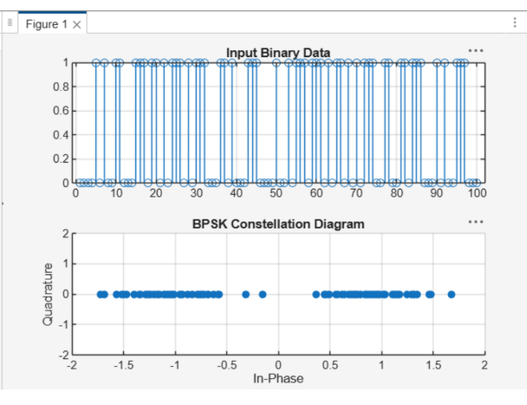

RESULT :
